# 1.Introduction

Based on the working principles of the deep learning Diffusion model and in combination with the project requirements, the following changes are made to the traditional model processing flow:

Firstly, the sample resolution we use is 512x512. Training directly with such a dataset requires high computing power, so it is more reasonable to adopt a cascade structure. We first generate a low-resolution image of 128x128 from random noise, and then super-resolve the adjustment of the low-resolution image to generate a high-resolution image of 512x512. Secondly, in each iteration of the diffusion model generation process, we introduce low-dose CT images and solve the MAP estimation problem to ensure that the generated images have good likelihood with the input low-dose CT images. Finally, based on the Gamma evaluation method, we evaluate the accuracy of the denoised images and FullDose images.

# 2.Material and Methods

## 2.1.Dataset

The access speed of the original link https://www.cancerimagingarchive.net/collection/ldct-and-projection-data/ is very slow. I found a related dataset on www.kaggle.com. I downloaded a total of 345 pairs of samples from folder C120 as the training dataset, and 10 pairs of samples from C081 for testing.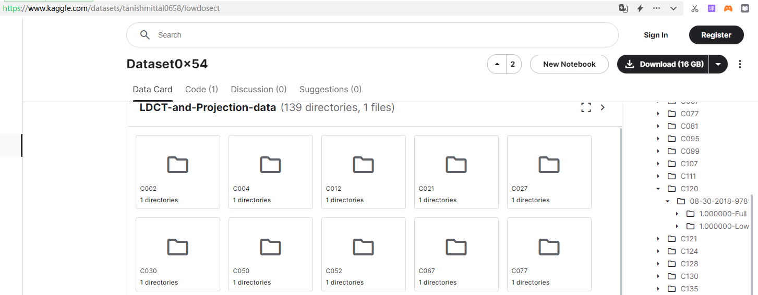

## 2.2. Preprocessing the format of the dataset

The dataset uses medical images in DICOM format. The biggest difference between this format and common photos is that the DICOM format not only contains image data but also includes a large amount of metadata information, such as patient information, inspection information, equipment parameters, etc., which cannot be involved in calculations. Before using it, we need to extract the image data from it, convert it into a numpy array, and then perform subsequent processing.

Another approach is to convert the DICOM images to PNG/JPG format first and then perform noise reduction processing on them. However, after comparative analysis, this method is not feasible because many details will be lost after conversion. If used as a training set, there will be significant errors inherently.

Below is a comparison of the same FullDose image after conversion. The left side is the original DICOM image, and the right side is the converted PNG image:

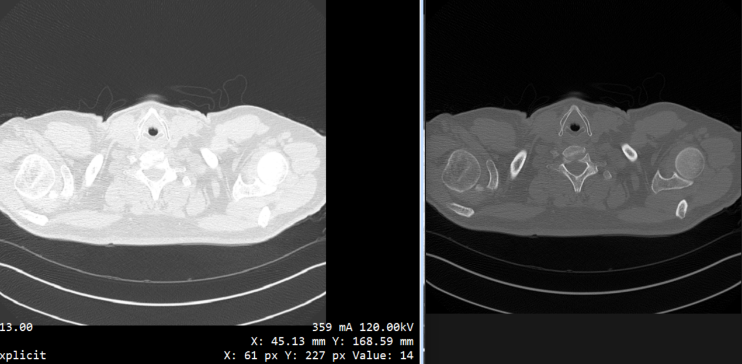

Therefore, it is necessary to extract image information directly from the original DICOM images for training and denoising, in order to ensure the accuracy of the dataset and the denoising process to the greatest extent possible. When processing, attention should be paid to the two parameters of WindowCenter and WindowWidth.

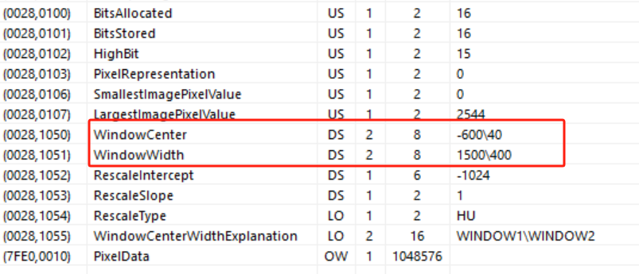

As shown in the figure, the processed image still retains the original DICOM metadata information.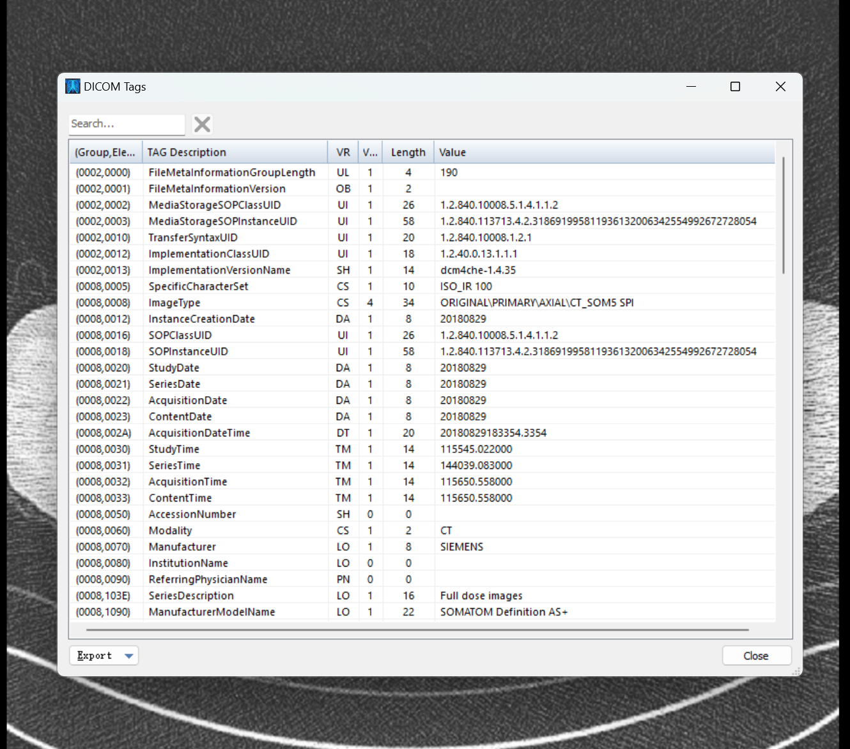

## 2.3. Set up an experimental environment of "local IDE + cloud GPU"

Due to complex computational processes and large model structures, involving multiple iterations, high-dimensional data manipulation, and complex probability calculations, training and inferencing large DDPM models require significant GPU resources. During the training phase, a cluster containing multiple high-performance GPUs is typically needed to support the entire training process. These GPUs can process data batches in parallel, with each GPU responsible for a portion of the model parameters, thereby accelerating the training process. However, completing the entire training process may still take weeks or even months. In the inference stage, although the computational load is reduced compared to the training phase, GPUs are still required to ensure real-time and high-quality generation. Relying solely on CPUs for inference can take tens of times longer, which cannot meet the real-time requirements of practical applications.

To meet the minimum requirement of 150 training samples, we have selected a consumer-grade RTX 4090 graphics card with 24GB of memory and CUDA support. Additionally, to achieve rapid deployment of the environment, we have chosen a "local IDE + cloud GPU" approach. This involves using local PyCharm to compile Python programs, connecting via SSH to an Ubuntu host with an RTX 4090 graphics card that supports the PyTorch framework, and utilizing remote GPU computing power to complete model training. The advantage of this approach is that it allows us to use a stable and familiar local IDE, eliminating the need for installation and migration hassles. Furthermore, remote GPUs can be easily scaled up or down, providing flexibility and convenience.

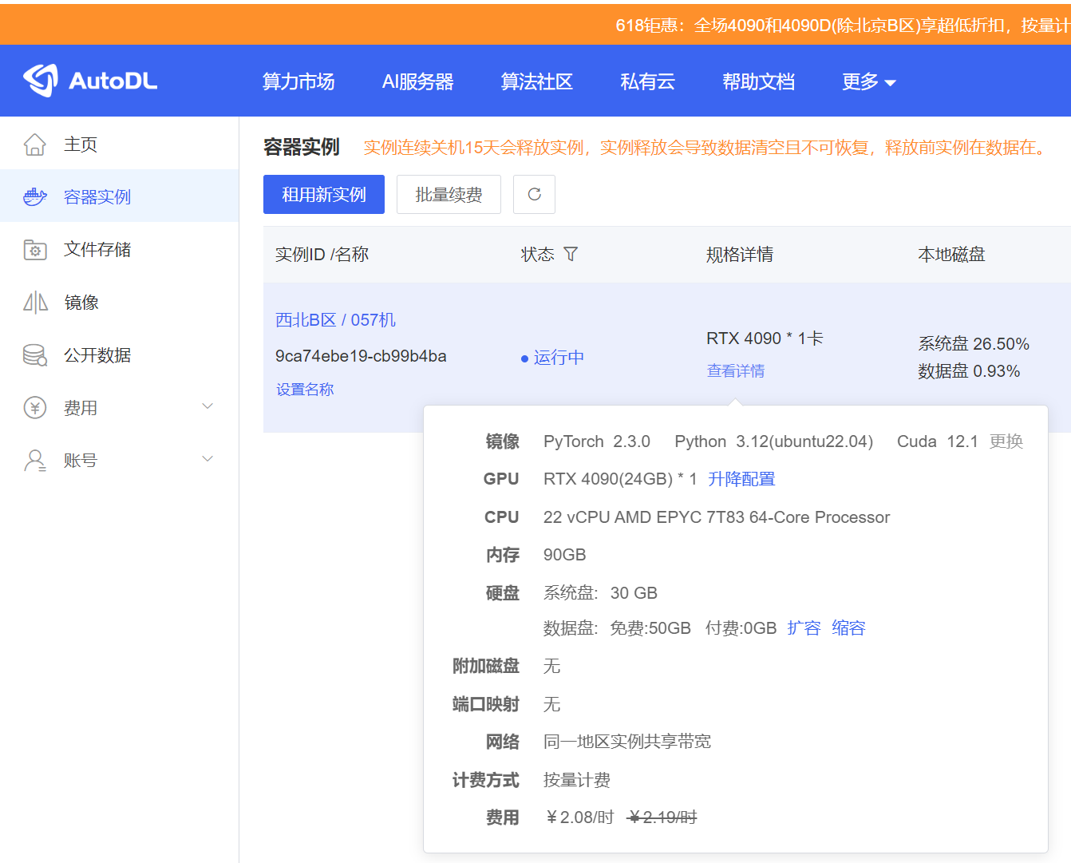

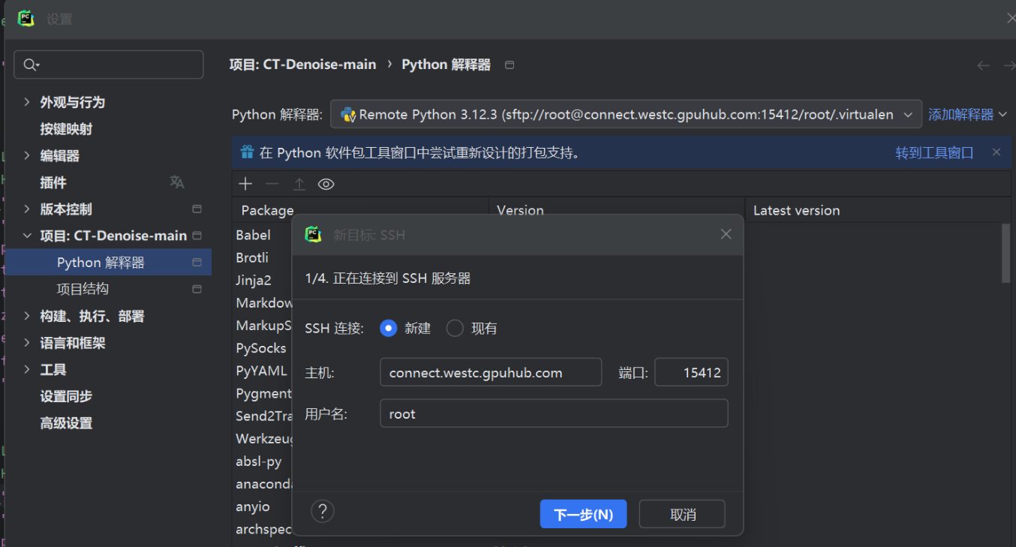

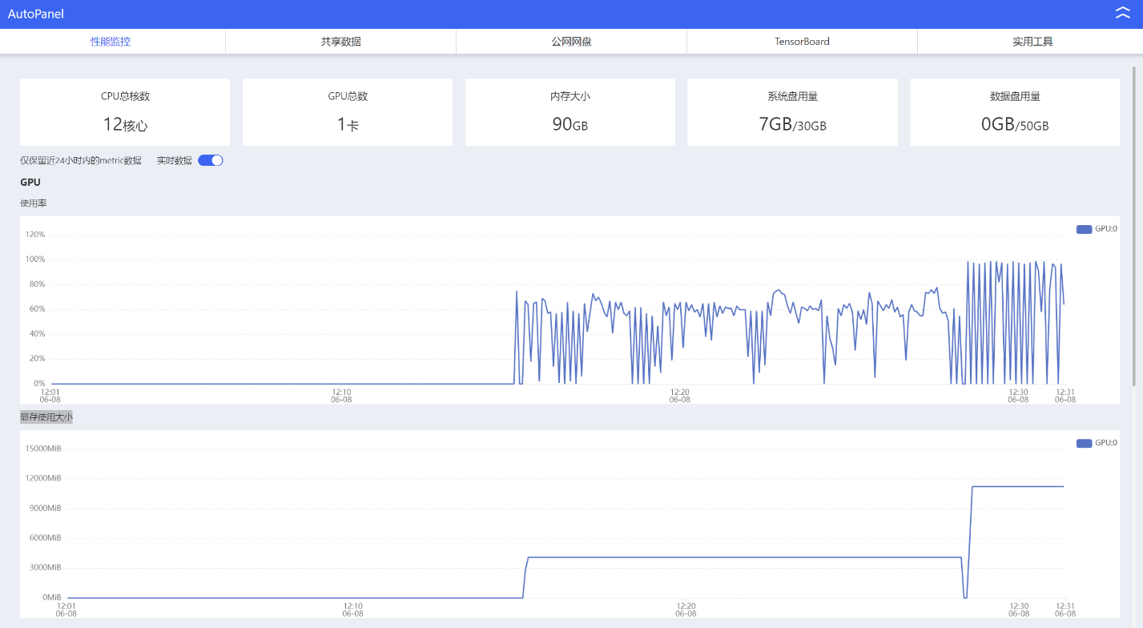

During the model training process, settings such as the number of layers in the U-Net and the size of the dataset have a significant impact on training speed and results. Therefore, it is necessary to configure these settings in combination with the GPU configuration.

## 2.4. Training a model with FDCT images

1. Unconditional diffusion model training

Generating a 128x128 low-resolution normal-dose CT image from random noise follows the normal model process.

* Forward process (diffusion process)：

Starting Point：

* Sample initial data points from the original dataset *x*0​。

Noise addition process：

* For each time step*t*（from *t*=1to *t*=*T*）, add Gaussian noise to *xt*−1​​​ to obtain *xt*。
* This process can be represented by the mathematical formula:

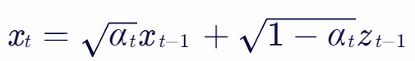 ​，where *zt*−1​ is noise sampled from a standard normal distribution, *αt*​=1−*βt*​，*βt*​ is a preset noise variance sequence, and 0<*β1*​<*β2*​<⋯<*βT*​<1。

* We can also express *xt* as a relationship with *x*0:

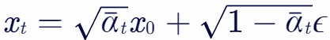

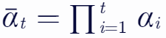Where ，and *ϵ*is the noise sampled from a standard normal distribution.

Ending point:

* When t=T, *,xt*​ will be almost pure Gaussian noise.

Implementation of the process：

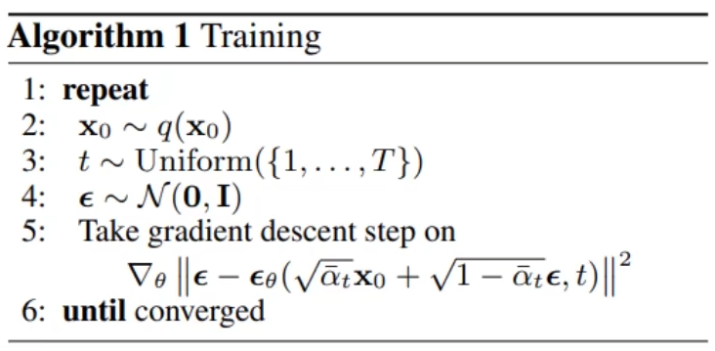

* Backward process (denoising process)：

Starting Point：

* Starting from the noisy data  *xt*

Predict noise：

* For each time step t (from t=T to t=1), use the model to predict the added noise ϵ at the curren *xt* and time step t.
* This prediction is usually achieved through a neural network, U-Net, which is trained to predict ϵ from *xt* and t.

Denoising process：

* Use the predicted noise ϵ and the known*αt*​ and *βt*​ to estimate *xt*−1​ of the previous time step.
* 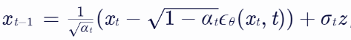 his process can be represented by the mathematical formula:： ，

where *ϵθ*​(*xt*,*t*) s the noise predicted by the model, and *σt*​  is standard Gaussian noise used to introduce some randomness.

Ending point:

* When t=0, the obtained *x*0 is the original data point recovered by the model from the noisy *xt*.
* Process implementation：

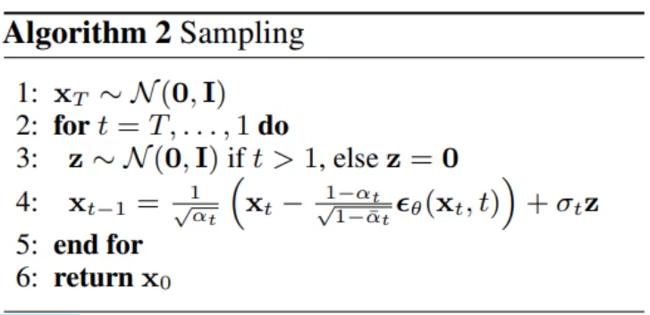

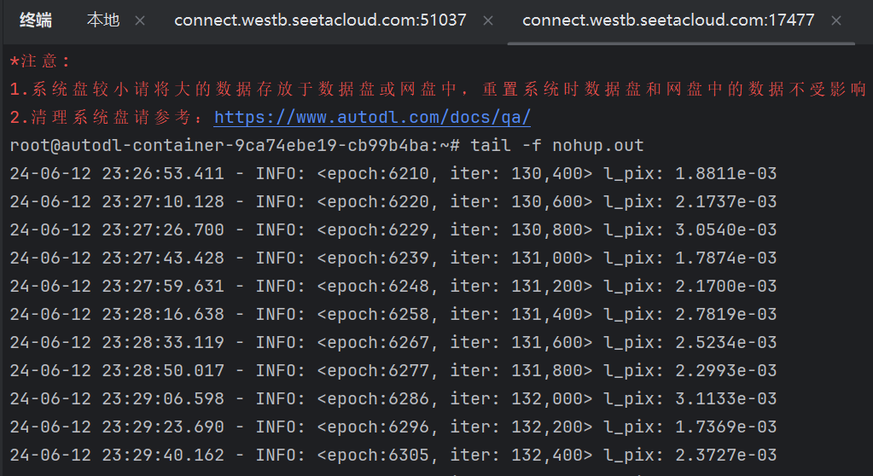

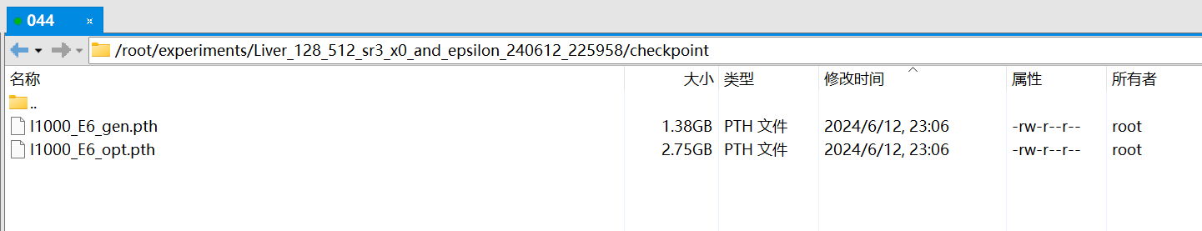

2. Conditional Diffusion Super-Resolution Model Training

Using 128x128 low-resolution images as conditions to generate 512x512 high-resolution normal-dose CT images. The difference between this and the previous unconditional diffusion lies in the use of FDCT images as additional conditions during the reverse diffusion process, controlling the generation of the observation sequence. Specifically, within a given dataset of image pairs, each sample's observation is associated with FDCT. In the forward process, the generation of the observation sequence is independent of it and is identically and independently distributed; whereas in the reverse process, the generation of the observation sequence is dependent on it. Thus, FDCT plays a role in controlling the generation process in the super-resolution model.

## 2.5. LDCT Image Denoising

First, a low-resolution low-dose image is obtained through downsampling. Then, the denoised low-resolution high-dose image is obtained through processing. Finally, a high-resolution high-dose image is generated through super-resolution.

Process implementation:

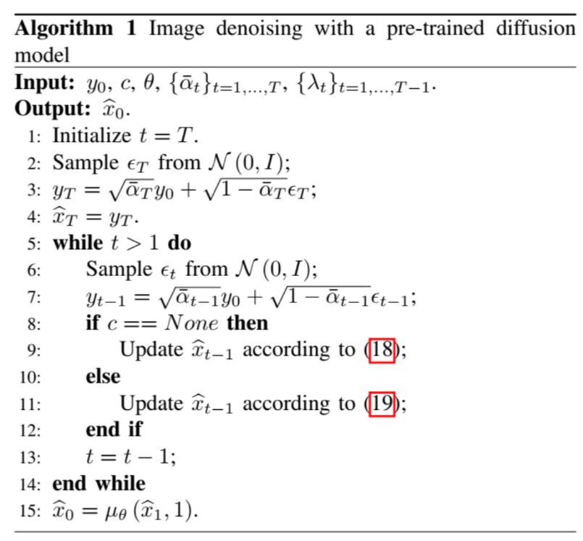

## 2.6. Gamma Evaluation

The 'Gamma 3%/3mm/10%' given as a model evaluation criterion is a standard for Gamma analysis, which is commonly used in radiotherapy planning verification to ensure the accuracy of dose distribution when patients receive radiotherapy. As our evaluation criterion, it is not directly used to measure the dose or distance attributes in the image, but rather to quantitatively evaluate the consistency of dose distribution and spatial distribution between the generated image and the full-dose CT image when the model processes CT images.

The following is a detailed method on how to use the 'Gamma 3%/3mm/10%' evaluation criterion to assess the accuracy of the model:

1. Interpretation of Evaluation Criteria:

* “3%” : This indicates that during evaluation, a dose difference within 3% is allowed.
* “3mm”:The distance from the difference to consistency is within 3mm.
* “10%” : When calculating the Gamma pass rate, only regions with a dose higher than a certain threshold (such as 10% of the full dose) are considered.

2.Evaluation applied to CT image denoising:

* Dose Difference: Although denoising does not directly involve physical changes in dose, we can treat the pixel values in the full-dose CT image as the "reference dose" and the pixel values in the denoised CT image as the "calculated dose". By comparing the difference between the two (expressed as a percentage), we can evaluate the accuracy of the model in preserving the dose information of the original image.
* Distance to Agreement: Here, distance does not refer to physical spatial distance, but rather to the difference in corresponding pixel positions on the image. By calculating the pixel value differences between the denoised CT image and the full-dose CT image at the same pixel positions, and considering whether these differences fall within a 3mm "tolerance range", we can evaluate the model's performance in terms of spatial distribution consistency.
* Threshold Processing: When calculating the Gamma pass rate, a dose threshold (10% of the full dose is used in this case) is set to exclude the influence of low-dose areas on the evaluation results. This is because pixel value changes in low-dose areas have less impact on image quality and may be more affected by noise and other factors.

3.Implementation Method：

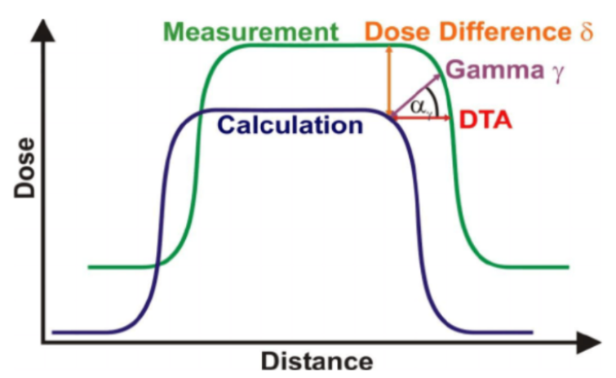

The basic concept of the Gamma algorithm is to establish a Gamma sphere, with any calculated point in the plan as the center, and find the shortest distance from this point, which is the radius of the circle that can be tangent to it. This shortest distance represents the two points considered by the Gamma algorithm for evaluation. It can be seen that the two points found by the Gamma algorithm have broader adaptability compared to the DTA and Dose Difference algorithms.

The formula:

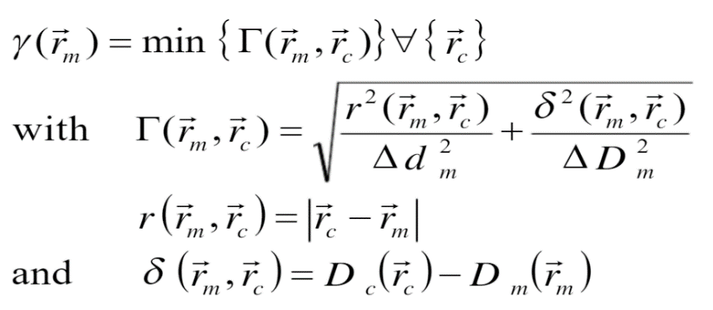

**4.** Implementation Process

* Initialization：

Convert the reference dose distribution map and the calculated dose distribution map into double-precision floating-point data for subsequent mathematical calculations. Set the dose difference criterion ΔD and the distance-to-agreement criterion Δd for Gamma analysis (typically as a percentage of dose difference and millimeters of distance difference). Create a zero matrix [Ir] of the same size as the input images to store the Gamma factor for each pixel. Determine the area in the reference dose distribution map where the dose is greater than 10% of the maximum dose, i.e., the [area] matrix, to exclude areas outside the body surface.

* Gamma Analysis：

Iterate through each pixel (i, j) in the reference dose distribution map. If the current pixel (i, j) is within the dosed area (i.e., area(i,j) == 1), perform the following operations:  
 Determine a search window centered at the current pixel (i, j) with a preset pixel size. If the boundary of the search window exceeds the image boundary, adjust the window boundary accordingly. Within the search window, calculate the distance d(kk, pp) and dose difference D(kk, pp) between each pixel (k, p) and the center pixel (i, j). Here, the pixel spacing ps is used to calculate the distance, and the dose difference is normalized to the maximum dose maximg. Calculate the Gamma factor ga(kk, pp) for each pixel (k, p), which is a function of the distance difference and dose difference. Find the minimum Gamma factor within the search window and store it in [Ir(i, j)].

* Pass Rate Calculation：

Iterate through the [Ir] matrix, count the number of pixels with a Gamma factor greater than 1, and divide it by the total number of pixels in the dosed area to obtain the proportion of pixels that do not meet the Gamma criterion. The pass rate r is the complement of this non-compliance proportion, i.e., r = 1 - non-compliance proportion.

Finally, the [Ir] matrix contains the Gamma factor for each pixel, and r gives the overall pass rate, which is used to evaluate the similarity between the calculated dose distribution map and the reference dose distribution map. A higher r value indicates that the two dose distribution maps are more similar; a lower r value indicates larger differences between the two maps.

。

5.Evaluation Process：

* Data Preparation: Use a set of full-dose CT images and corresponding low-dose CT images as test data.
* Model Application: Apply an AI-based large model to perform denoising on the low-dose CT images.
* Gamma Analysis: Conduct Gamma analysis on the denoised CT images and the full-dose CT images, calculating the Dose Difference (DD) and Distance-to-Agreement (DTA). Count the proportion of pixels that meet the "Gamma 3%/3mm/10%" criterion, known as the Gamma Passing Rate (GP%).
* Evaluation Criteria: Evaluate the model's performance based on the Gamma Passing Rate. If the Gamma Passing Rate is above 95%, it indicates that the model has retained good dose distribution and spatial distribution consistency in the denoising process. A rate of 88% is considered the minimum passing standard.

# 3.Results

Ten pairs of samples from C081 were used for testing, with LowDose images serving as the input source. After denoising, DICOM images were output and evaluated using the Gamma criterion. The output passing rate results showed that all ten pairs of samples achieved a passing rate of over 92%, meeting the evaluation standard.

1、C081-020：Gamma Passing Rate：99.4%

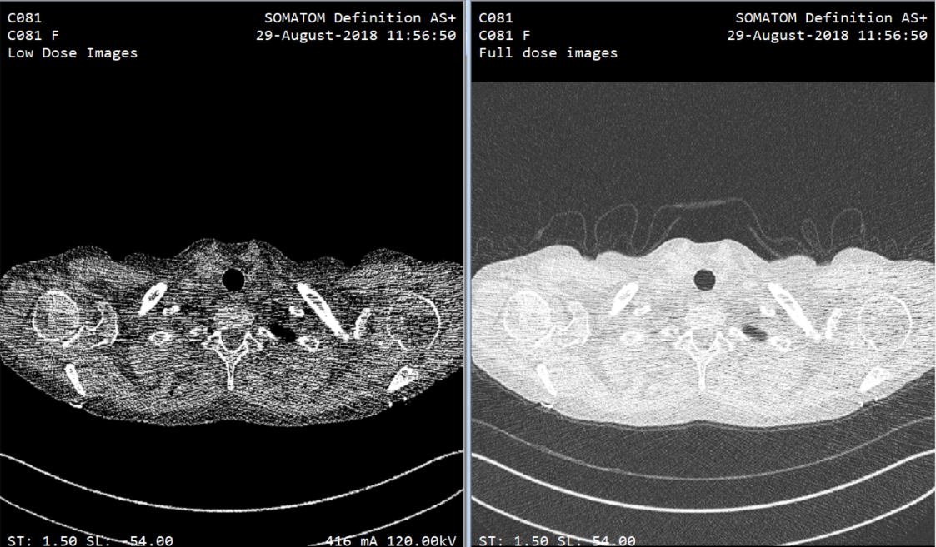

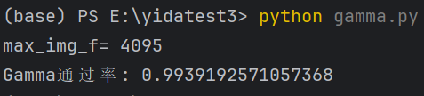

2、C081-040：Gamma Passing Rate：99.7%

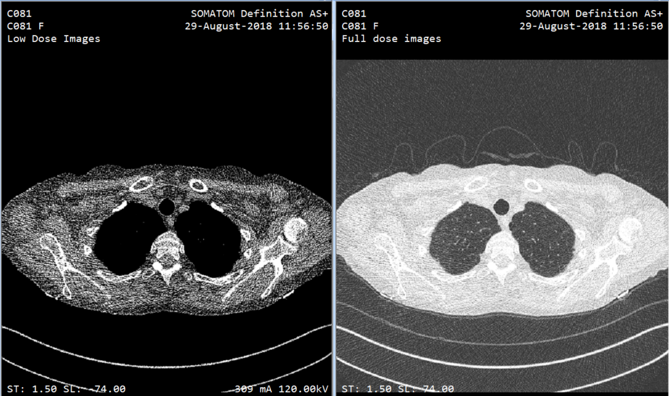

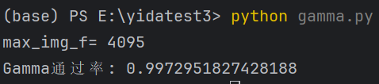

3、C081-060：Gamma Passing Rate：98.3%

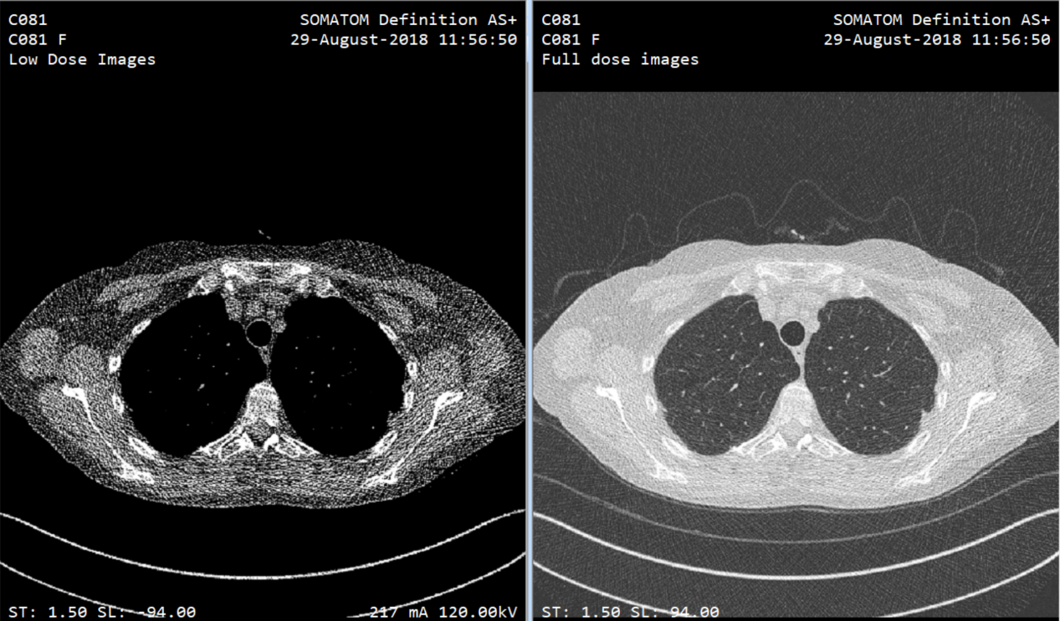

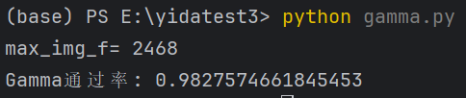

4、C081-080：Gamma Passing Rate：98.4%

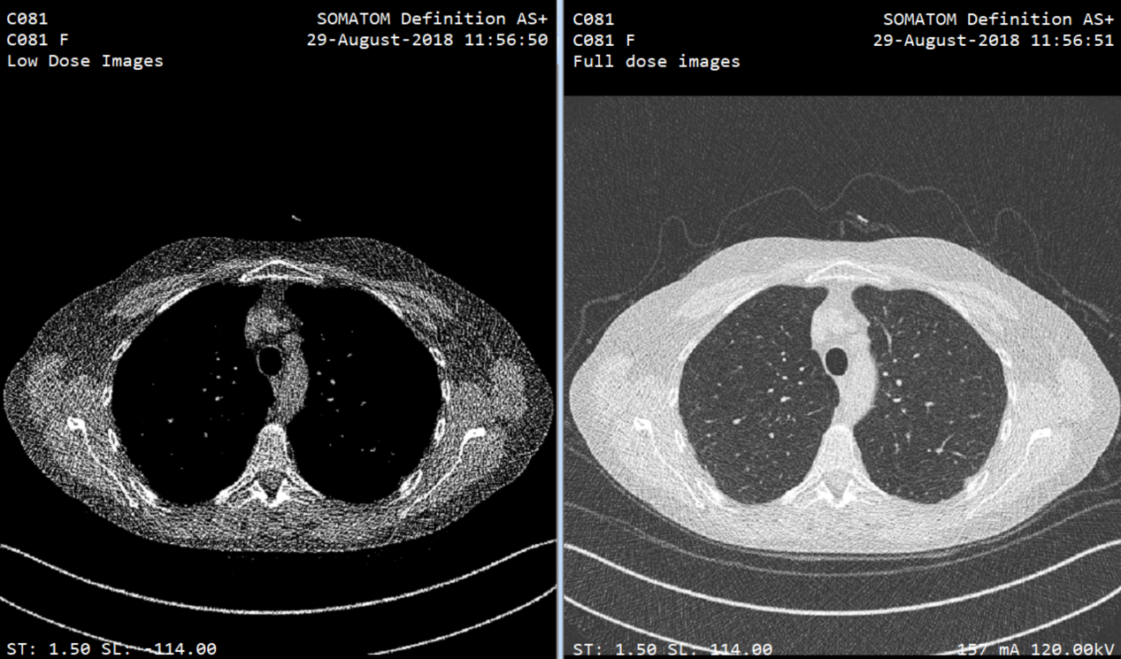

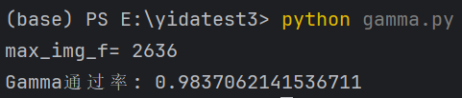

5、C081-100：Gamma Passing Rate：97.4%

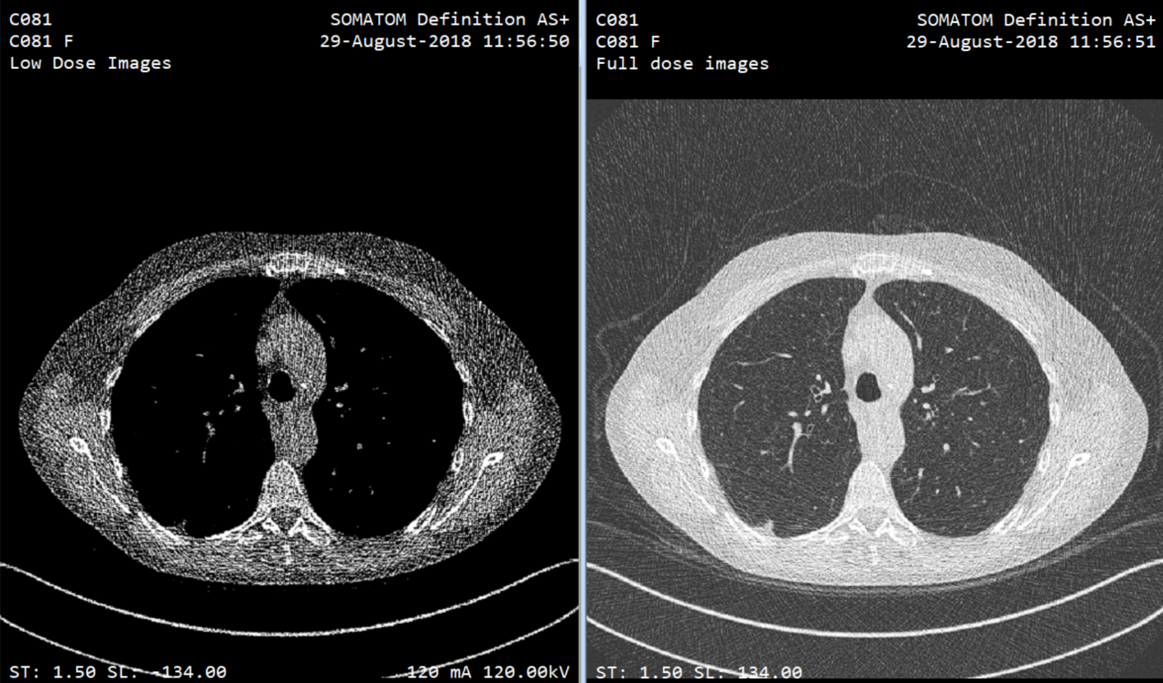

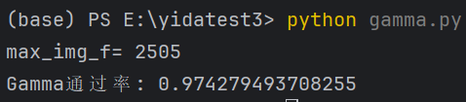

6、C081-120：Gamma Passing Rate：96.6%

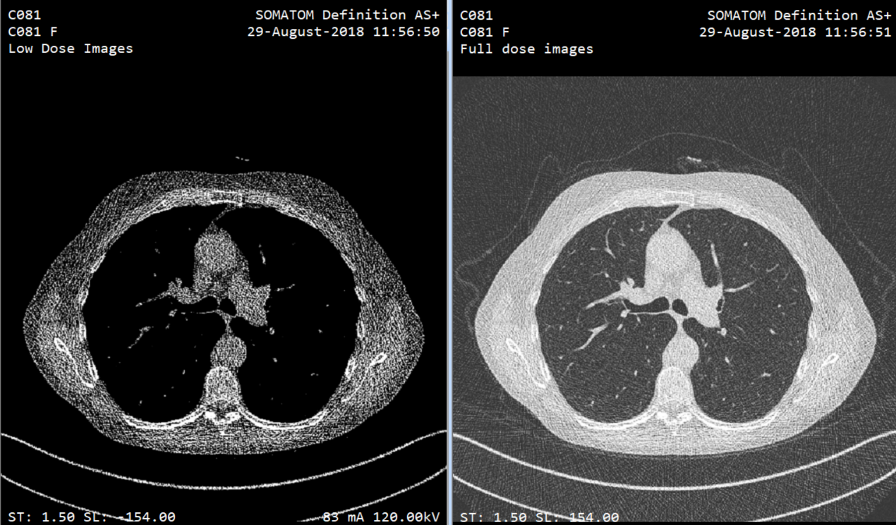

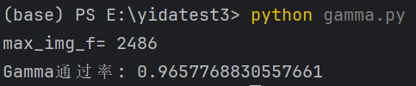

7、C081-140：Gamma Passing Rate：97.1%

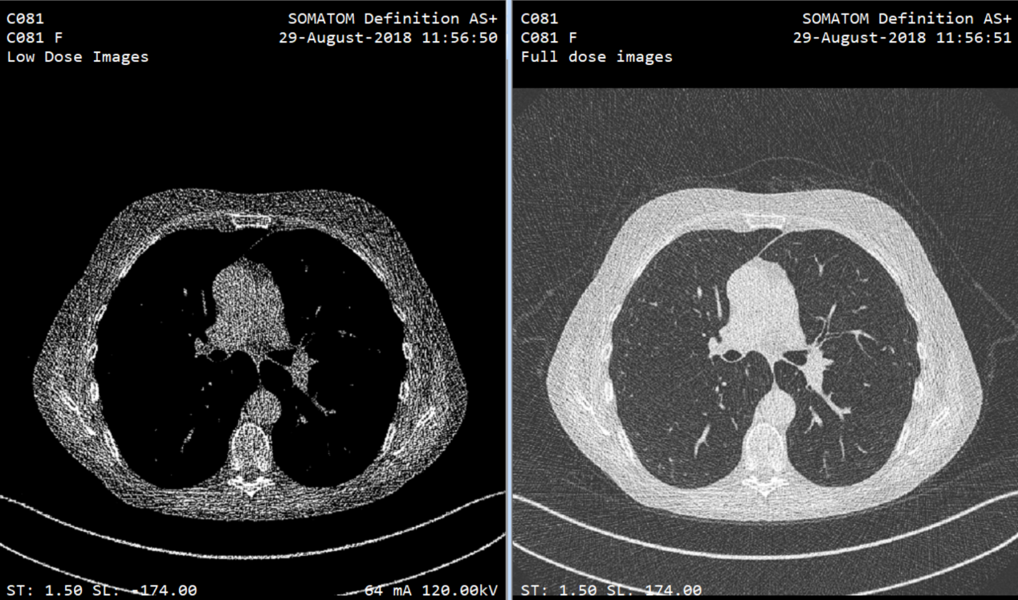

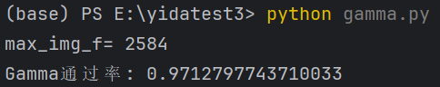

8、C081-160：Gamma Passing Rate：96.5%

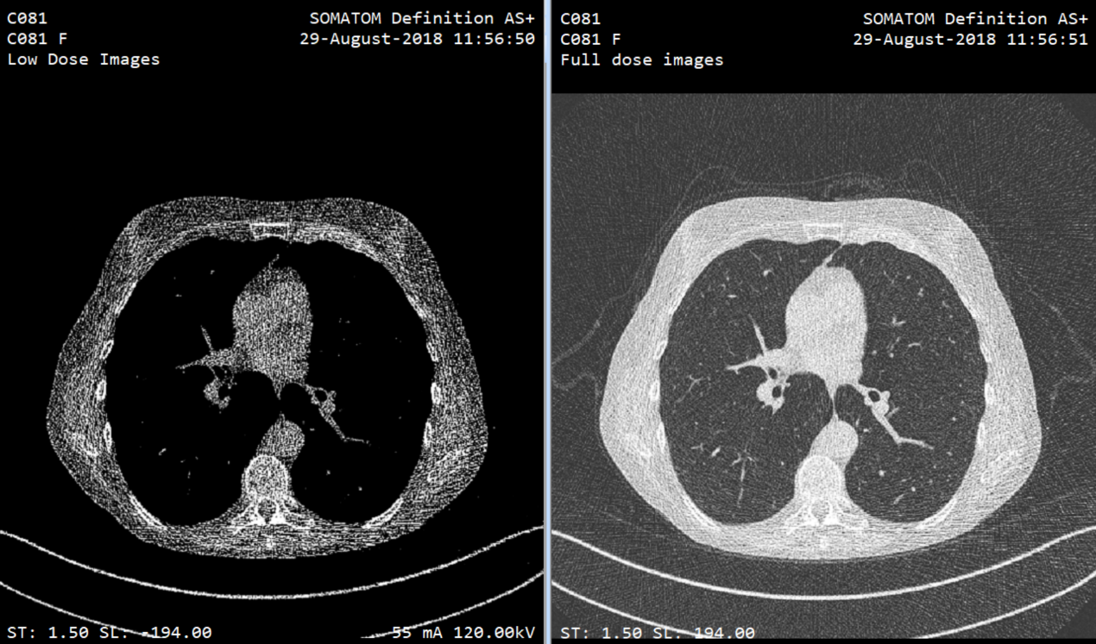

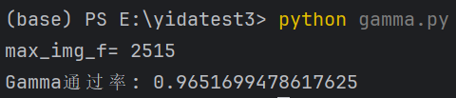

9、C081-180：Gamma Passing Rate：96.6%

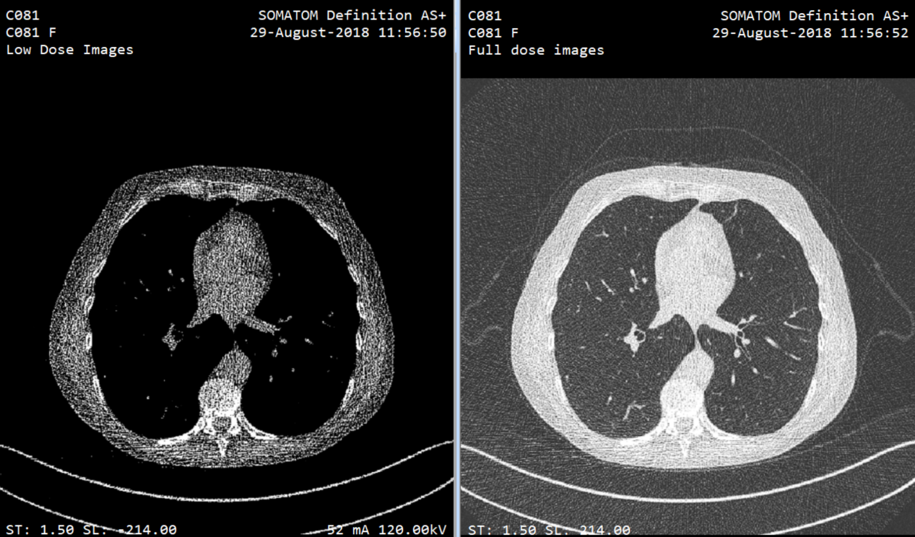

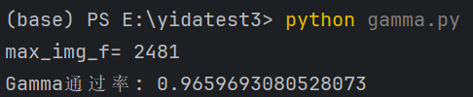

10、C081-200：Gamma Passing Rate：97.6%

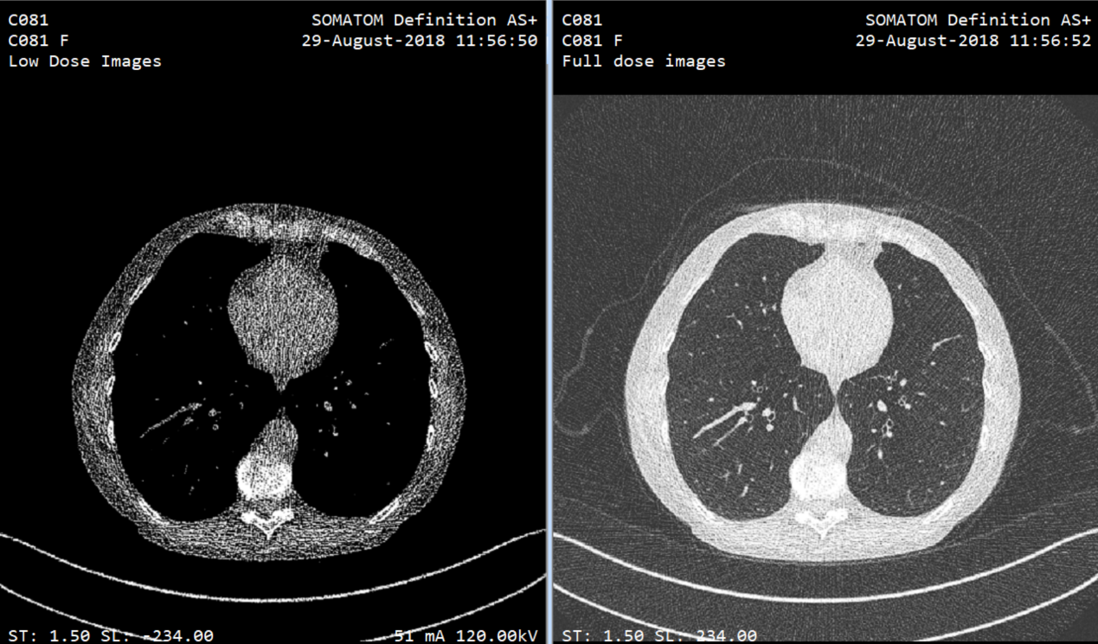

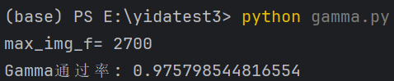

# 4.Discussion

During the process of image compression, especially when using lossy compression methods, some image information will be inevitably lost. This information loss cannot be fully recovered during subsequent denoising and super-resolution processing, which may result in reduced details or distortion in the final image. However, this is also a balanced result with computing capabilities. Super-resolution reconstruction is an ill-posed inverse problem, meaning there are multiple possible solutions when restoring a high-resolution image from a low-resolution one. This implies that the reconstruction result may not be unique and may not accurately restore all the details of the original high-resolution image.

Additionally, the setting of weights during training plays a pivotal role in DDPM model training. It not only affects the denoising effect of the model but also directly relates to the convergence speed, generalization ability, and the diversity and quality of the generated images. Therefore, in practical applications, it is necessary to reasonably adjust these weight parameters based on specific tasks and dataset characteristics.

# 5.Conclusion

Importing DICOM images through the current Diffusion model, compressing, denoising, and super-resolving them to obtain original resolution high-definition images is a feasible method, and the results can meet the Gamma evaluation passing standard of 92%. At the same time, performing denoising after compression can significantly reduce the required GPU computing resources, and a consumer-grade RTX4090 graphics card can fully meet the computing requirements. However, it is important to note that when processing, one should not attempt to change the format of DICOM images, otherwise, it will affect the accuracy of data training and inference, and the Gamma evaluation metrics will lose their meaning.